For decades, some farmers have applied more Phosphorus (P) onto their soil in hopes of helping those crops get the jumpstart they need. The problem is that P is often fixed and not available to the plant.

So how do you know that you are getting the most out of your Phosphorus investment? How can you ensure that the P that is applied is actually available to the plant? The AVAIL T5 Placement Chart can help pinpoint fields and soil zones that stand to benefit from AVAIL® T5 Phosphorus Enhancer technology. AVAIL T5 helps unlock that P that is fixed in the soil, making it available for the plant. AVAIL technologies result in 30-45% more phosphorus being made available to the crop, according to field trials.

To see the AVAIL T5 Placement Chart, visit vlsci.com/AVAILT5.

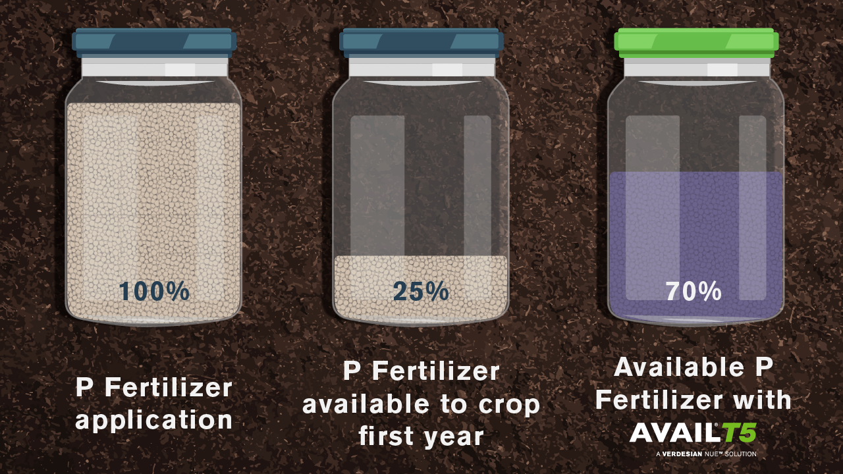

AVAIL® T5 Phosphorus Enhancer technology results in 30-45% more phosphorus being made available to the crop, according to field trials. Learn more at vlsci.com/AVAILT5 or talk to your ag retailer today.

