New Five Star Cooperative Customer Portal

- Go to our website: https://www.fivestarcoop.com/
- In the upper right-hand corner click “Login” and you will be redirected to the login page.
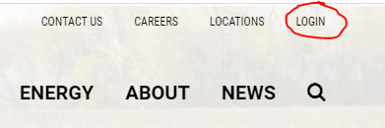
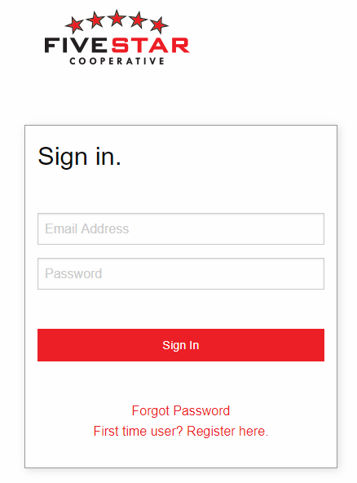
- This is what the login page should look like. Here you will enter your email address and password that you setup previously. If you do have a new account on this portal, please reach out to Heather at Five Star or sign up by clicking on “First time user? Register here.”

- This is what our new Customer Portal will look like, everyone’s page can look different than others depending on the type of business each person does with Five Star.
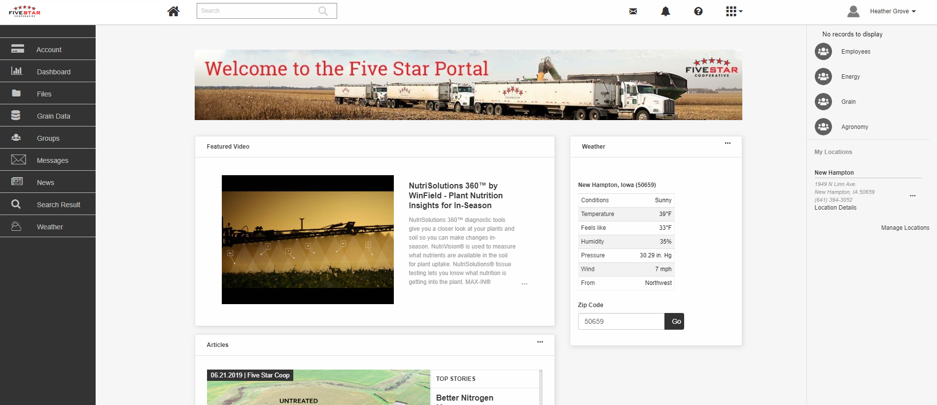

- There are a couple ways to get into your Grower360 account to pay bills and view statements etc. On the top of the screen, you will see a box with 9 little squares in it with a down arrow. This is where you will click to link to your Grower360 account. If you are first time user, it may take a few minutes for the link to your Grower360 to be setup. You may also click on the big red box on your dashboard page for your Current Balance.
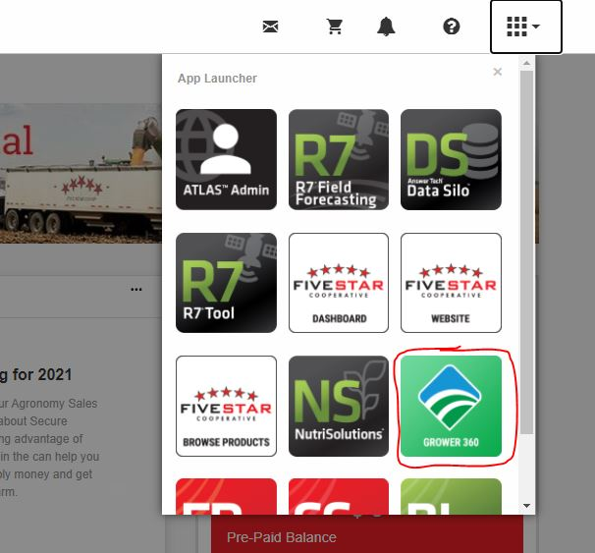
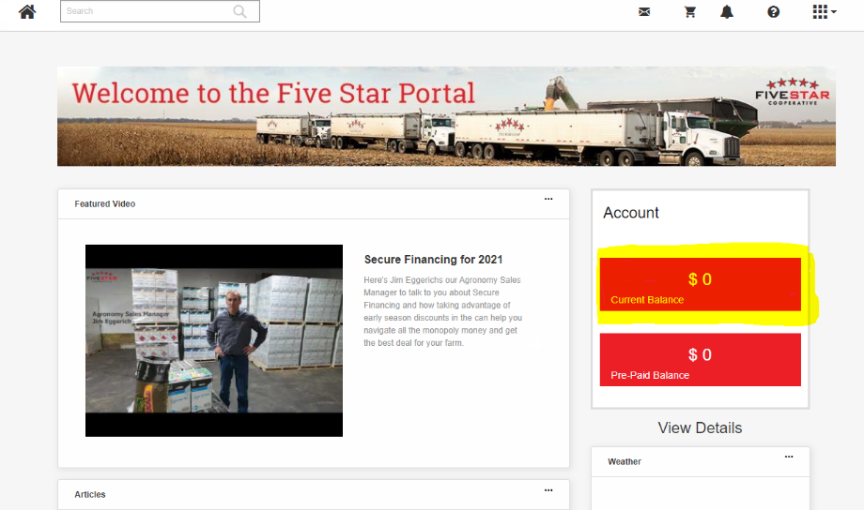

- This is what the Grower360 portal will look like. It will show your regular balance due, prepay balance, etc. As you can see the account used in the example does not do any grain business with Five Star, so no Grain information is showing. If you are a Grain customer your Grain activity will show as well.
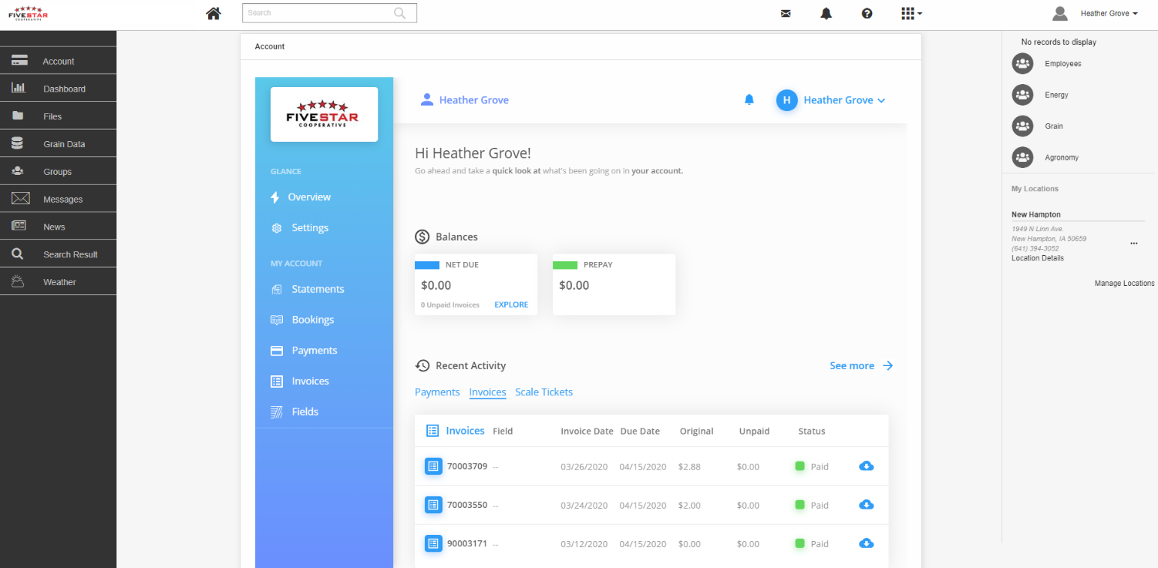

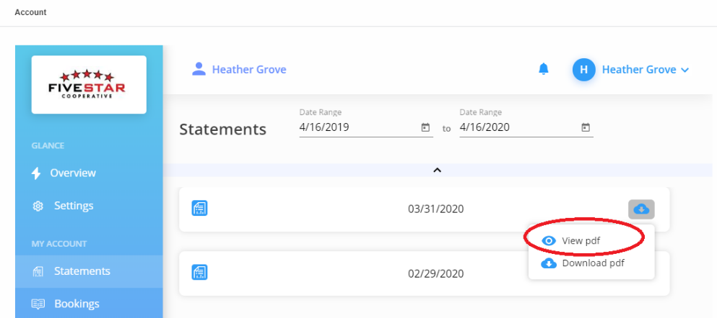
- Most places you see the blue cloud with an arrow in it, you can click to view or download the pdf image of that transaction.

- To make a payment on your account, on the Overview page click inside the Net Due Box. This will take you to the payment window.
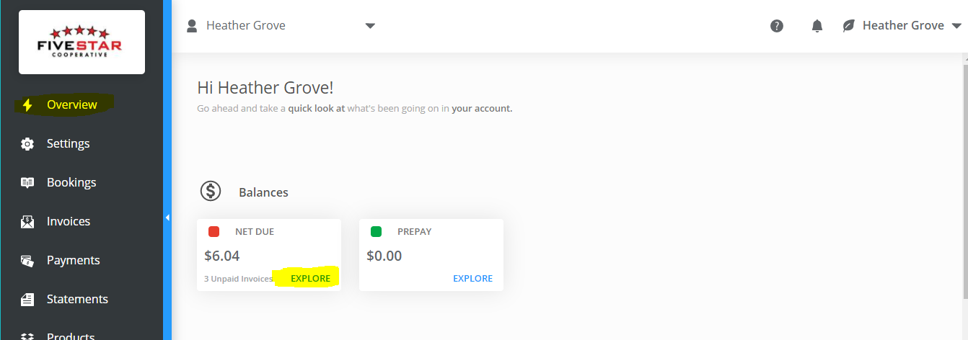

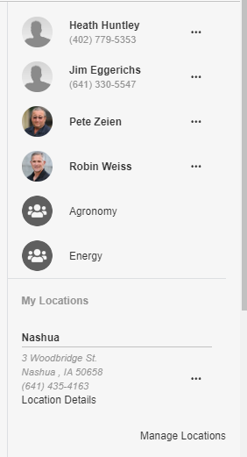
- Back on the Five Star Portal on the right-hand side of the screen you will be able to see any contact info about employees you may work with at Five Star. You will also see some group’s pages like the Agronomy and Energy groups shown in the image below. These groups will be a forum page for our customers and employees to share information back and forth with multiple customers at Five Star. You can post pictures of stuff you are seeing in your fields and comment on posts other customers are talking about. You can also see the locations listed that your mainly do business with. These locations can be changed and edited at any time if you would like to see others.

- Across the top there are a few more menu options. The first option is the envelope. This is an email feature that is within the Portal. You can email back and forth with your salesman data or images, etc. The second is a link to take you to our online shopping page if you are setup with access.

- There will be many changes and features added to this Portal coming in the future. We feel it will be the next step in better serving our customers in our ever-changing times, so be on the lookout. Please reach out with questions and concerns.
Heather Grove – heather.sternat@fivestar.coop – 641-394-3052

