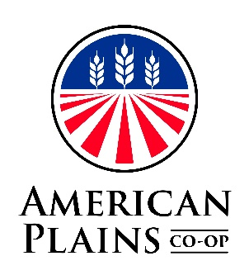
Membership Application
For Participation and Written Consent

The undersigned INDIVIDUAL , CORPORATION , PARTNERSHIP ; does hereby apply for Common Stock Membership, or Nonvoting Membership in THE GREAT BEND COOPERATIVE ASSOCIATION DBA AMERICAN PLAINS CO-OP, Great Bend, Kansas, and agrees to conform to the Bylaws of this association.

The undersigned is / is not a producer of agricultural products.

The undersigned, a patron of THE GREAT BEND COOPERATIVE ASSOCIATION DBA AMERICAN PLAINS CO-OP of Great Bend, Kansas. Does hereby consent to include in his gross taxable income, the stated dollar amount of any distribution with respect to his/her patronage which are made in written notices of allocation and which are received by him/her from this cooperative in the taxable year in which such written notices of allocations are received by the undersigned in the manner provided in 26 U.S.C. 1305 (a). The undersigned does hereby consent and agree to treat the stated dollar amount of all per-unit retain certificates received by the undersigned in connection with products marketed through the cooperative as representing cash distribution which the undersigned has constructively received, and which has been reinvested in the cooperative. The said “Consent” is REVOCABLE pursuit to the EXPLANATION below.

The undersigned herby acknowledges receiving a copy of the Bylaws of THE GREAT BEND COOPERATIVE ASSOCIATON and further acknowledges receiving a copy of the credit policy of THE GREAT BEND COOPERATIVE ASSOCIATON and limitations as set forth in the Bylaws and Credit Policy, and any amendments thereto.

Under the penalties of perjury, I certify that the information provided on this form is true, correct, and complete, and that I am NOT subject to back-up withholding pursuant to the Internal Revenue Code, Section 3406 (d).

Dated this day of , 20 . Telephone:
Social Security Number -- -- . FIN Number:
Applicant: Date of Birth:
Address:

Signature: Title: Date:

Signature: Title: Date:

Signature: Title: Date:

If Partnership, all partners sign. If Corporation, President and Secretary sign.

EXPLANATION
The forgoing consent is revocable by the member in a writing received by the association, PROVIDED HOWEVER, that such revocation is effective with respect to patronage occurring after the close of the association’s fiscal year during which said written revocation is received. THE PATRONS/MEMBER’S CONSENT IS REQUIRED FOR THE COOPERATIVE TO RECEIVE AN INCOME TAT DEDUCTION FOR ITS PATRONAGE ALLOCAIONS, pursuant to Subchapter 1 of the Internal Revenue Code of 1954, Sections 1381 thru 1388. By signing said consent, the patron agrees to include the total amount of any patronage allocation or dividend (not just the cash portion) in his/her gross taxable income in the year during which qualified written notice of allocation is received. While you are required to sign the forgoing consent, it is related to you only to the extent that your purchases form the Association or sales to the Association that are related to your taxable income.

